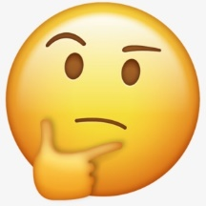

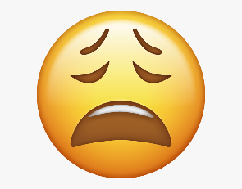

PSHE Vocabulary Year 3
How well do I know the word?
I’ve never heard the word before
I’ve heard this word but I don’t know what it means
I know what this word means but I can’t explain it.
I know what this word means and I can use it in a sentence.
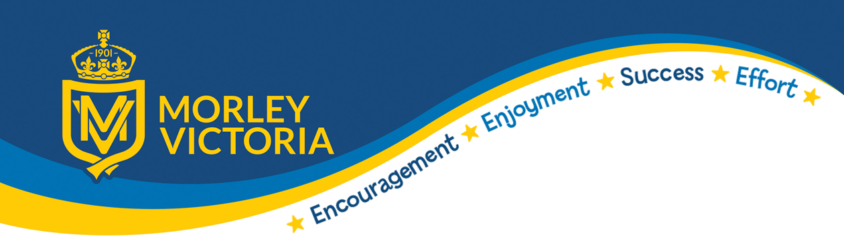

KEY VOCABULARY
Value for Money Drug Gender Culture Belief
Community Conscience Bullying Bystander
Challenges Put-downs Set-backs Brands
Democracy Tolerance Individual Liberty Mutual Respect Rule of Law
Kindness Respect Honesty Permission Generosity.

