

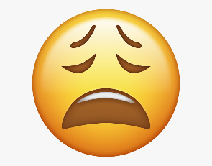

PSHE Vocabulary Year 5
How well do I know the word?
I’ve never heard the word before
I’ve heard this word but I don’t know what it means
I know what this word means but I can’t explain it.
I know what this word means and I can use it in a sentence.
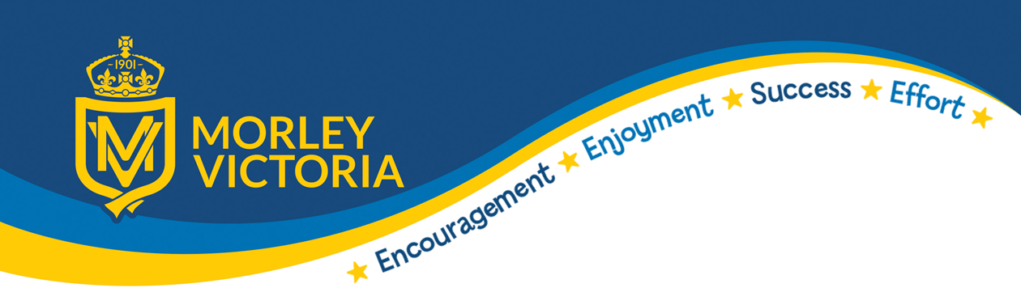

KEY VOCABULARY
Loan Interest rates Enterprise e-cigarettes Peer-pressure Bereavement
Stereoptype Diversity Discrimination Relationships Potential Risks
Domestic Violence Conflicting Emotions Grief Media Manipulation
Democracy Tolerance Individual Liberty Mutual Respect Rule of Law
Kindness Respect Honesty Permission Generosity.

