

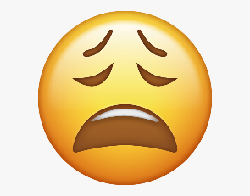

PSHE Vocabulary Year 2
How well do I know the word?
I’ve never heard the word before
I’ve heard this word but I don’t know what it means
I know what this word means but I can’t explain it.
I know what this word means and I can use it in a sentence.


KEY VOCABULARY
Medicine Symptoms Asthma Hazard Risk
Consequences Friendship Portion Healthy
Biological Differences Life Cycle Care
Kindness Respect Honesty Permission Love Generosity

