ELECTRICITY
WHAT WILL WE BE LEARNING? (KNOWLEDGE)
9
DIAGRAMS

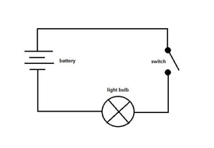
Simple Circuit
We will learn about which common, everyday appliances run on electricity.
We will learn how to construct a simple series circuit, identifying and naming the basic parts (cells, wires, bulbs etc.) and how to add a light source to our circuits.
We will learn how switches work in circuits and how they can open and close a circuit.
We will learn about insulators and conductors and which materials make good conductors.


READING
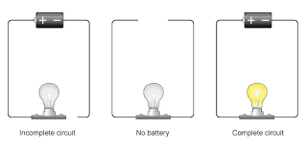
Complete Circuit vs Incomplete Circuit
Pre topic and post topic in fluency lessons from topic book boxes, Twinkl and Classroom Secrets.
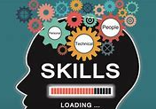
SCIENTIFIC ENQUIRY (SKILLS)

QUESTION PREDICT PLAN MEASURE & RECORD CONCLUDE EVALUATE
We will investigate how to make a simple circuit.
We will investigate the effect of adding more parts to a simple circuit.
We will investigate and observe how a light bulb works.
We will investigate the differences between insulators and conductors and which materials fit into each category.

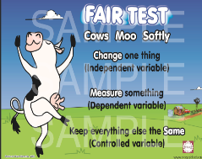
LINKS TO MATHS
CROSS CURRICULAR

RE: How is light used in Hinduism?
Record data in tables, use Venn Diagram English: explanations, methods

