Did your grandparents play with an Xbox?
WHAT WILL WE BE LEARNING? (KNOWLEDGE)
CHRONOLOGY
Things that happen before now are called the past – it is also called history.
Things from the past happen in an order – this is called chronology.
Things were different now to 50/60 years ago (when grandparents were born) – these include toys, clothes, technology and attitudes.
How things are different from the past to now – what to look out for.
What is a decade and century?

Present day - 2019
Grandparents born – 1950s/60s

Children born – 2014/15
Parents born – 1980s/90s

BOOKS
Non-fiction – then and now books
Dogger
Christmas at the toy museum
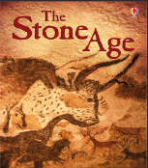
WHAT HISTORICAL SKILLS WILL WE USE?
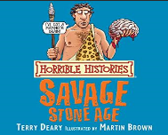
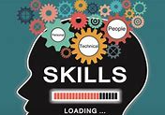
CHRONOLOGYENQUIRY CAUSE & CONSEQUENCE COMPARESIGNIFICANCECHANGE
Chronology – can you construct a timeline of your own life?
Enquiry – what were things like for our grandparents/great grandparents?
Comparison – similarities and differences between toys in the past and now?
Significance –
Change – What has changed in the last 50/60 years?

English – Geography – Morley then vs now
Science – Materials – toys use different DT – making toys
Art – Computing – Technology then and now
SMSC –
CROSS CURRICULAR

