CLIMATE ZONES: CAN A POLAR BEAR LIVE IN BRAZIL?
WHAT WILL WE BE LEARNING?
MAP

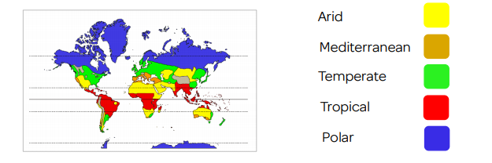
We will learn how to identify lines of latitude.
We will learn know what the world’s climate zones are.
We will learn about the features of different climate zones and compare these.
We will learn about the polar regions – Arctic and Antarctica.
We will learn all about the Mediterranean.



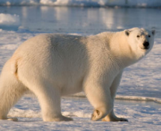
WHAT GEOGRAPHICAL SKILLS WILL WE USE?
BOOKS

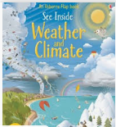
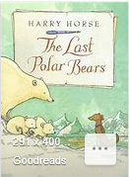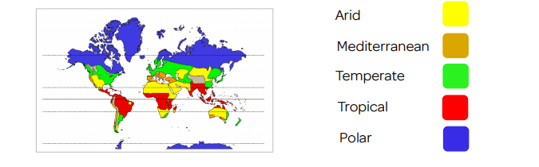
LOCATIONAL PHYSICAL HUMAN GEOGRAPHICAL SKILLS AND FIELDWORK
Map work – Can you identify countries, features and regions?
Physical – Can you compare different climate zones?
Human – Can you compare the populations, jobs, living conditions etc?
Fieldwork – Can you collect and compare rainfall over a period of time?
Compare – Can you present work in charts and graphs to compare
rainfall and temperature?


English – Novel: The Last Polar Bears Computing – Digital/ Computer mapping
Science – The Water Cycle Maths – Graphs and charts
SMSC – New environments and how people live

CROSS CURRICULAR

