A home guide to using Morley Victoria Knowledge Organisers and the Stages of Knowing Words

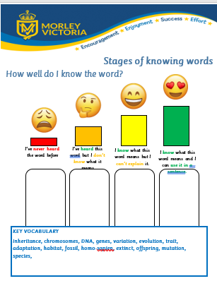
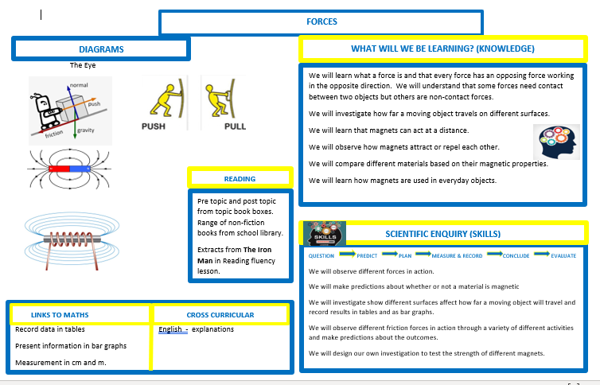
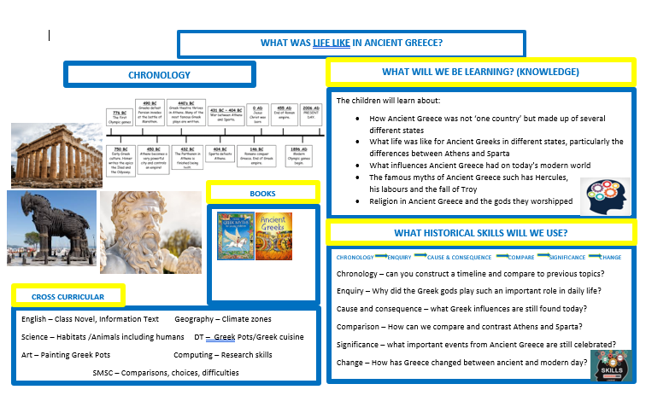
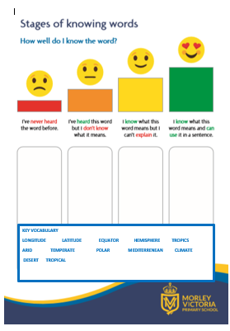

Over the last year at Morley Victoria we have introduced Knowledge Organisers and the Stages of Knowing Words as part of our curriculum development. These are designed to make it clear to the children what they will be learning over the course of a topic and what we expect them to know and remember by the end of the unit of work. These are just the essential points that they will learn: they will cover a lot more than this. However, these outline the essential knowledge or ‘sticky knowledge’ which we want the children to retain.
Sticky Knowledge
What do we mean?
Sticky Knowledge is effectively knowledge that will stay with us forever. In other words, an alteration has happened to our long-term memory. We could divide sticky knowledge into two main parts. Firstly, interesting facts that will remain with us forever and secondly, knowledge that children need to learn as part of the national curriculum.
Sticky Knowledge

Interesting facts, such as: almost 50% of all plants and animal species can be found in the rainforests.
Knowledge required for the national curriculum: Year 1: Know the names of the four countries that make up the UK.

Many of you have asked how to support your child at home with foundation subjects. The following guide will provide some ideas on how to use these documents at home to support your child.

Mind Mapping

The first thing to do is to read the Knowledge Organiser together with your child. Knowledge organisers will be made available at the start of each topic to help them remember what they are learning and to help them to see the bigger learning journey in their subjects. Instead of forgetting previous learning, students will continually revisit and retrieve prior learning from their memories. We don’t expect you to have all the knowledge around all the subjects in history, geography and science so you could use the helpful guides to get your own knowledge up to speed or extend the children’s learning further. These guides won’t match exactly the documents we use, as these are made bespoke by the teachers for their year group, however they could prove helpful. The knowledge organisers contain the minimum knowledge we want the children to retain from the topics.

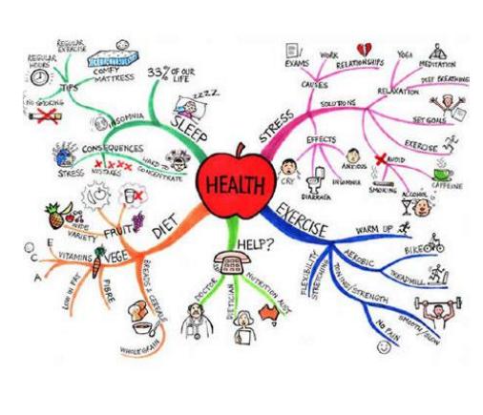
Mind mapping is a great tool to help children retain information in their long-term memory. This could be a combination of key words, sentences or pictures that trigger associations in the brain. As the topic progresses, get your child to keep adding more information or different strands to the mind map by referring to the knowledge organiser. Once you have the mind map you can:

- Research a key question from the knowledge organiser and add more to your mind map.
- Cover up a section of the mind map and see how many key words/images that your child can remember.
- Give them a blank piece of paper and a time limit. Starting from scratch. How much of the mind map can they recreate?

Pop Quizzes

We are more likely to remember something if we encounter it more than once, we have to break the forgetting cycle! By regularly making yourself retrieve things from your memory will build a far stronger long-term memory. There are many different ways of practising retrieval and we must use a range of ways to ensure the knowledge sticks. One effective way is to have low stakes ‘pop quizzes’. We have a knowledge quiz at the end of each topic but do short retrieval quizzes throughout.
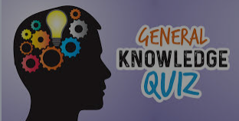
Some example questions:

- Name two foods that are a source of carbohydrates.
- What is the function of the ribs?
- What are the three time periods of the Stone Age?
- What is the job of the heart?
- Name the four countries of the UK.
- Can you name all the continents?

Any questions the children get wrong you can then look up together for the answer. These can be done at home, in the car, on the way to school etc

Vocabulary Practise

Children need to be exposed to a word a minimum of 30 times to help embed them retain it in their long-term memory. These are fun games you can use to get to that point using the word list on the Stages of Knowing Words.
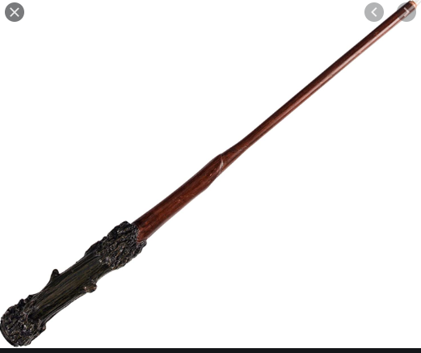
Vocabulary Duel

Take it in turns to say one of the words from the list. Whoever
gets the last word wins – no repetition allowed!

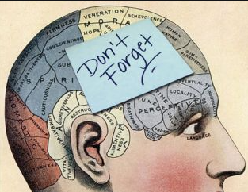
Memory Game
Give children a set time to study the words on the list. Turn the page over and see how many words they can recall. Repeat until they can get them all or take it in turns with your child to see who wins!

Vocabulary Definitions
It is important that children understand the meaning of the word in the correct context of the subject. Some words used in the subjects the children may have encountered before e.g. inheritance and same are specific to that subject e.g. longitude and latitude. The stages of knowing words goes from red (never heard of the word) to green (I know what the word means and can put it in a sentence). By the end of the topic the aim is to have most or all the words in the green column.
At home you can keep asking your child if they have learnt the word yet and which
column they feel the word belongs in and update their stages of knowing words accordingly.
You can look up the word together if they are unsure of its meaning.

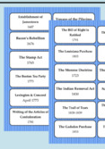
Flashcards
Write the word on one side and the definition or answer on the other. Practise doing both
until the child is secure in their understanding of the word.

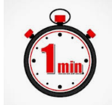
Just a Minute
Give children a word from the list and they have to put it in a sentence/provide a definition.
See how many they get in a minute and try and beat that record.
Further Support
Reading Materials
Our school library and class libraries/reading corners all have quality texts linked to the topic the children learn at school. The Morley Library also has a range of fantastic books to offer.

Websites and subscriptions
Our website provides links for extra learning and support to use at home. Children also have links to subscriptions for certain subjects such as Odizzi in geography which they can use.

Trips
There are lots of free activities that children can do in the holidays. See the link below for 50 free activities in Leeds:

https://leeds-list.com/culture/free-things-to-do-in-leeds/

