David Hockney

WHAT WILL WE BE LEARNING?
Important work
We will learn who David Hockney is.
We will learn where David Hockney got his inspiration from.
We will learn why abstract art became popular during the 1950’s and 1960,s
We will learn what the main characteristics of abstract art are.

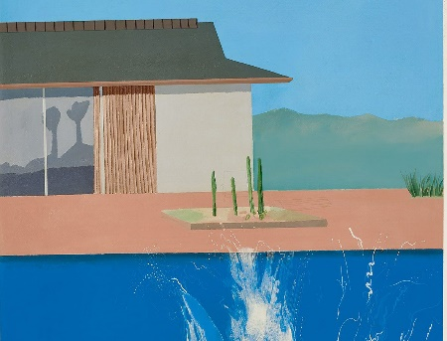
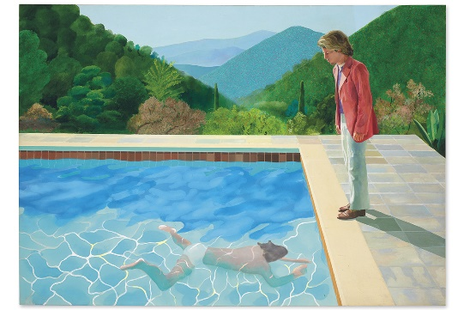

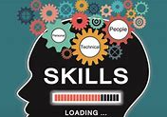

Most expensive work so far “The bigger splash”
WHAT WILL WE LEARN TO DO?
Abstract Art definition
Abstract art: is modern art which does not represent images of our everyday world. It has colour, lines and shapes (form), but they are not intended to represent objects or living things. Often the artists were influenced by ideas and philosophies. Abstract art is found in painting and in sculpture.

We will learn to compare work of different artists.
We will learn how to create abstract art from 1950s/60s.
We will learn how to create all the colours we need.
We will learn how to use our sketchbooks to adapt and improve our original ideas.
We will create a piece of art work in the style of David Hockney

