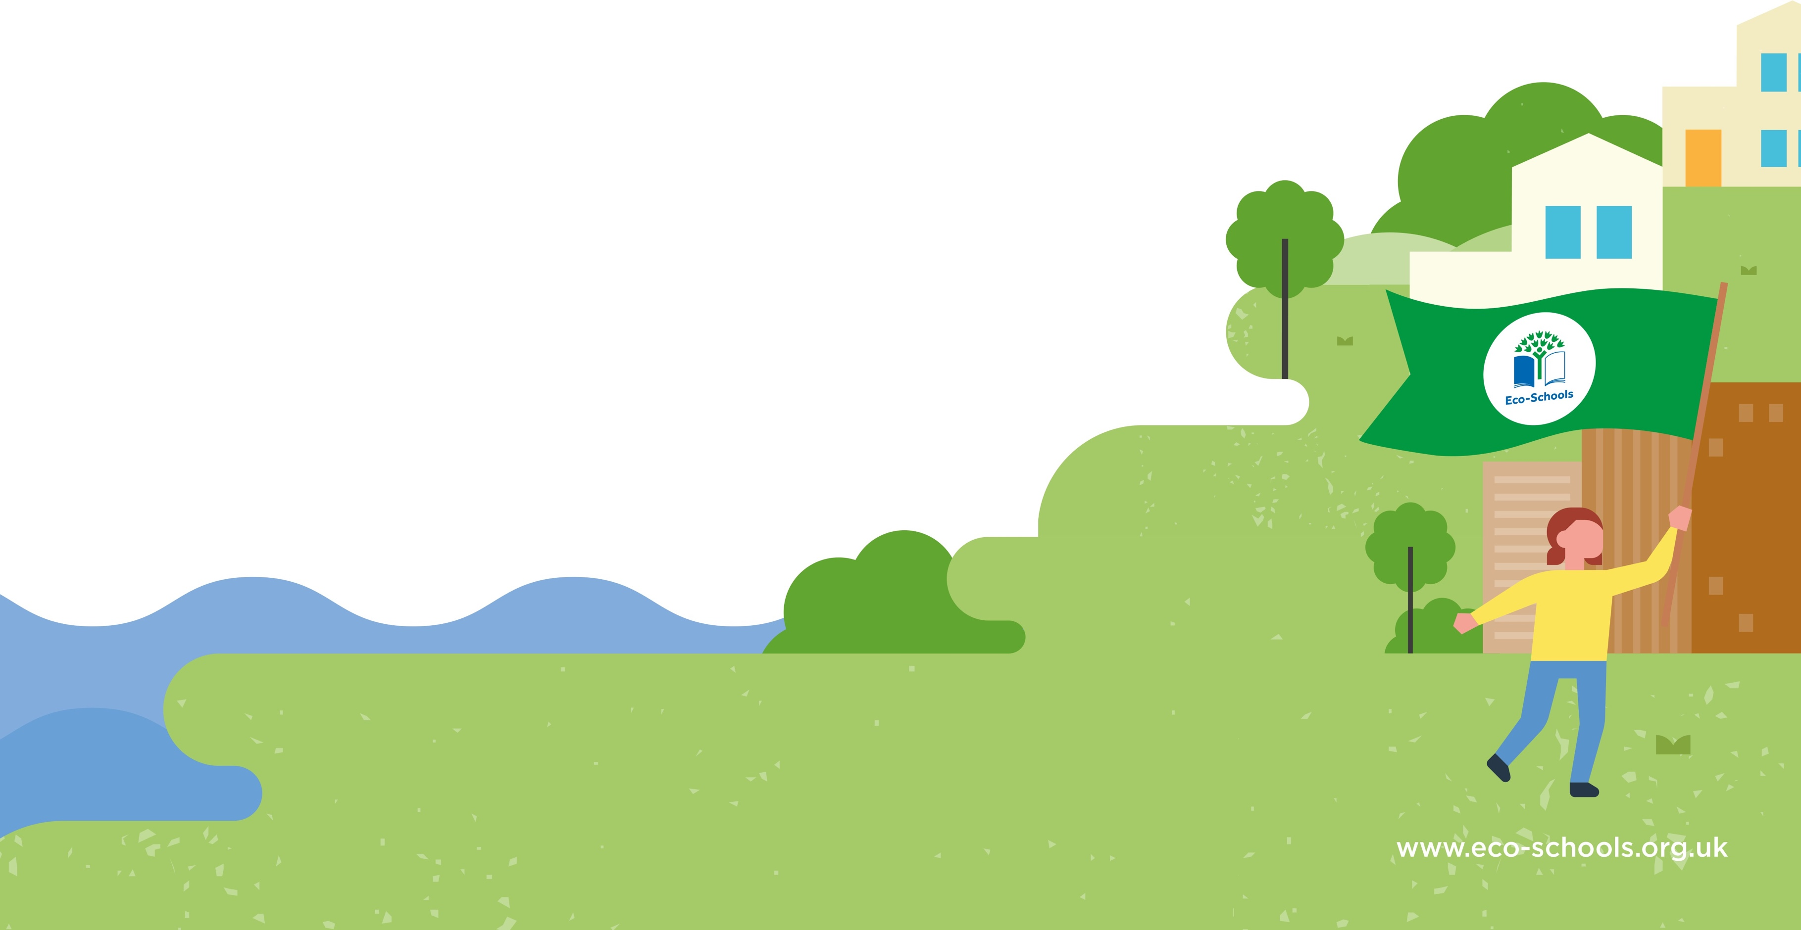
- Aim:
- To ensure all classrooms have a recycling and waste bin.

- To reduce litter and waste around school.

Action(s):

Plant some climbing ivy across the fences at the front of school in order to reduce gases and pollution coming from the road. This will help to make sure the front playground is safe and healthy.
How we will monitor progress:
- KS2 eco-warriors to water plants.
- Measuring of the growth.
- Pollution measure before and after.
Evaluation:
How long will it take?
Up to 1 year onwards for time to grow.

Who is responsible?
Miss Smith
Eco-Committee to support planting.

Date: 9/11/2023
How long will it take?
2 weeks to a month

Who is responsible?
Eco-Committee

How we will monitor progress:
- survey what is going in the ‘general waste bins now’
- Survey what is going in each bin after one month
Evaluation:

Action(s):
- Create posters to encourage recycling and rubbish separation.
- Litter monitors across school.
- Check bins around school and in classrooms.

Eco-Schools Topic:
Waste and Recycling

Action Plan
Aim:
To lower pollution coming from the surrounding roads on the front playground.
Eco-Schools Topic:
School Grounds

