WHAT WILL WE BE LEARNING?
Climate Change – Year 6
Images
- About the Intergovernmental Panel and discuss the key findings
- Examine current trends in global climate emissions and conclude if they are rising or falling.
- Understand the term ‘climate tipping points’ and why this connects with a need for urgent action
- Through looking at current impacts begin to predict future impacts depending on the level of heating
- Look at local and global responses to climate change forming opinions and discussing what makes effective action
- Look at the carbon footprints of individuals, organisation and countries. Use this to develop ideas about responsibilities now and in the future.
- Understand that awareness of an issue does not always lead to actions exploring the reasons behind this
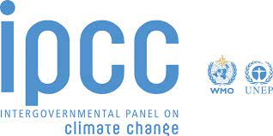
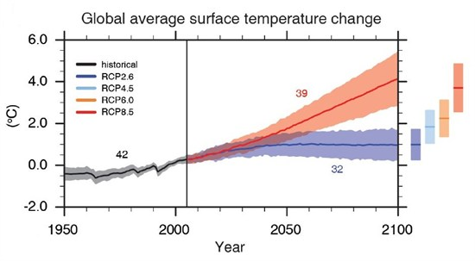



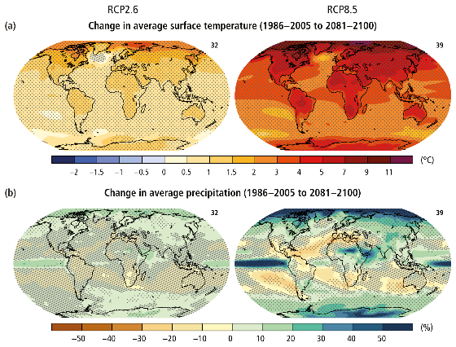
Books/Websites
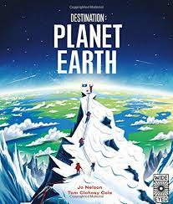
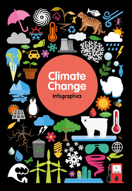


LOCATIONAL PHYSICAL HUMAN GEOGRAPHICAL SKILLS AND FIELDWORK
Geography:
- Identify the impact of humans on physical features of Earth
- Look at locational differences and how some countries are impacted more than others.
- Examine global emissions trends discussing the countries that produce more gases than others and why this is.
- Link natural disasters with the climate crisis and the changing trend.
Science:
- Create our own investigations to explore the impact of climate change on different regions.
- Develop our scientific terminology creating hypothesis and evaluating our results.
PSHE: - development of empathy and discussion of climate justice
Writing: speaking and listening
- letters to local authorities
- Non-chronological repsorts
WHAT SKILLS WILL WE USE?

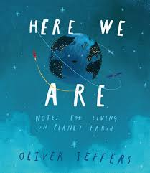

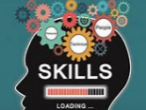
CROSS CURRICULAR
Art – Political art
SMSC – New environments and how people live, Moral questions, choices etc.
Maths – Looking at a variety of graphs and gathering data
Outdoor learning – encouraging respect for the environment and understand the benefits of healthy living and nature
History – Look at how climate change ahs evolved and the impact of the past on the future

