STONE AGE
KNOWLEDGE QUIZ
Why was it called the Stone Age?
What are the three periods of the Stone Age?
Which period lasted the longest?
What is Stonehenge?
What did foragers have to be careful of?
Name three extinct animals from the stone age

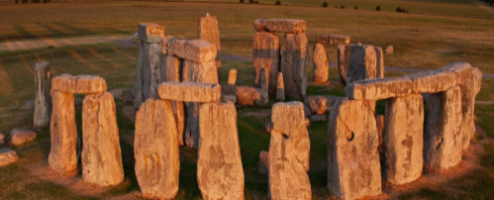


SKILLS TESTER

CHRONOLOGYENQUIRY CAUSE & CONSEQUENCE COMPARESIGNIFICANCECHANGE
- Can you put these periods of history in chronological order?
Vikings Neolithic Paleolithic Ancient Greece Ancient Egyptians Anglo Saxons
- Give one theory of why Stonehenge was built.

- Compare how humans got their food from the early Paleolithic to the late Neolithic

- Discuss ways in how human dwellings changed from the Paleolithic to the Neolithic.

- Why was Skara Brae so important?




