DO YOU THINK YOU COULD HAVE SURVIVED THE STONE AGE?
CHRONOLOGY
WHAT WILL WE BE LEARNING?
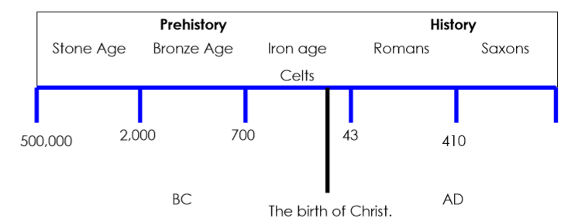
The periods of the stone age and how long they lasted.
How humans evolved to live through these times.
The roles and methods of hunter gatherers.
What is Skara Brae and why it is important.
The theories of why and how Stonehenge was built.
What prehistoric animals there were and their importance.

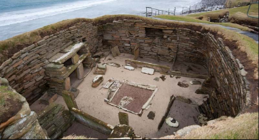

BOOKS

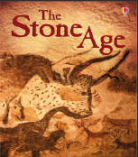
WHAT HISTORY SKILLS WILL WE USE?
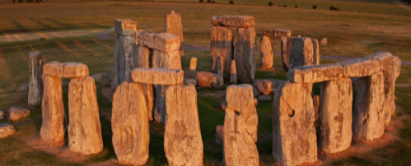
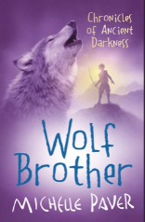
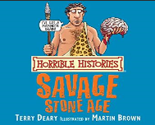
Chronology – can you construct a timeline and compare to previous topics?
Enquiry – why can we not be certain about Stonehenge?
Cause and consequence – what changes helped humans adapt and survive?
Comparison – how could you have survived the stone age?
Significance – what important events/landmarks are from the stone age?
Change – What changed for humans/the planet during the stone age?


English – Class Novel, Information Text Geography – Climate change
Science – Link with Evolution DT – Stonehenge models
Art – Sketching Computing – Research skills
SMSC – Comparisons, choices, difficulties
CROSS CURRICULAR

