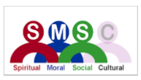
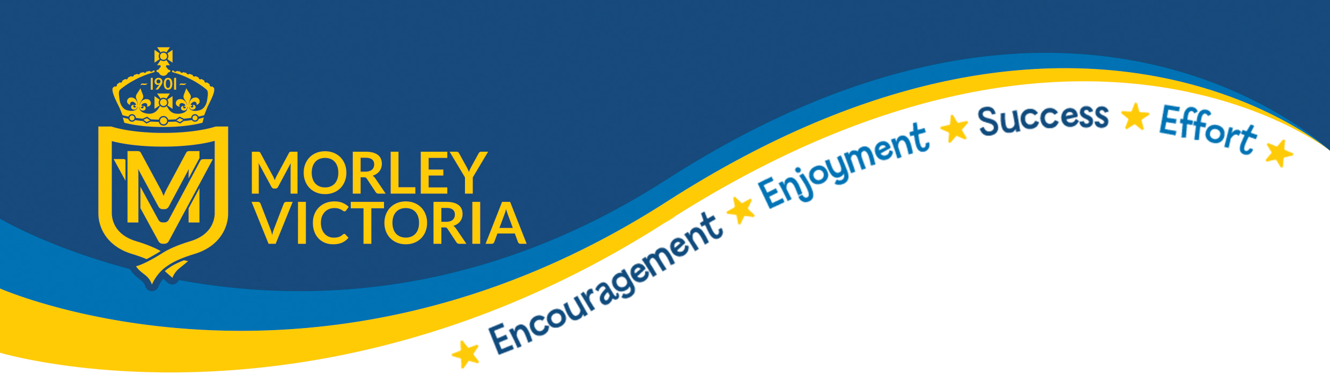

SMSC and History
Spiritual Development
The study of History involves a sense of curiosity and the mystery of how and why events in the past happened, how this has changes the way we live today and raises questions as to what could have happened if events had had different results. Artefacts, visits and visitors are used to give pupils a sense of the past and aid pupils in understanding the people who produced and used these objects. Pupils are encouraged to explore the role played by important individuals, for good or ill, in the shaping of the world we live in. Pupils also reflect upon the different interpretations of the past and how these interpretations have been made.

Moral Development
Pupils are asked to consider and comment on moral questions and dilemmas. Events and beliefs in the past will often be at odds with what we would consider unacceptable today (and were to some people in the past also). Pupils will be encouraged to show compassion for people facing dilemmas and to empathise with decisions which people in the past made and the reasoning behind these decisions. Notions of right and wrong are explored in connection with events from the past, linking with the value of justice. Our key term ‘parliament’ will explore this and link with British values.

Social Development
Pupils will explore the similarities and contrast between the past and present societies and be made aware of how, in the main, we are very fortunate to live in ‘the modern world’ which links with the value of thankfulness. They will examine how other cultures have has a major impact on the development of ‘British’ culture. Pupils will be encouraged to build up their own social development through collaborative and team working activities. The study of social issues is a common theme in History lessons. They will look at how ‘Empires’ and ‘Civilizations’ developed and what made them successful and what didn’t work.

Cultural Development
Pupils will study and be encouraged to gain an understanding of and empathise with, people from different cultural backgrounds. One of our key enquiry terms is ‘migration’ which links strongly to our black history curriculum and also our work towards the CCQM award and our PSHE curriculum. They will examine how other cultures have has a major impact on the development of ‘British’ culture. Pupils develop a better understanding of our multicultural society through studying links between local, British, European and world history. The contribution of different cultures to human development and progress are studied, which links with the values of wisdom and endurance. Our black history is threaded through our long term plams.

