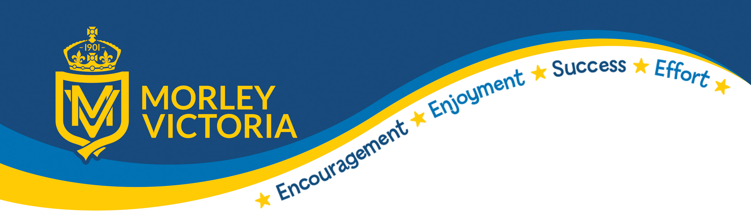

Subject: History (including Black History)

Intent  (What is the aim and purpose of your subject at MV?) | - To ensure that our children have a good understanding of chronology and the order in which key historical events have occurred and shaped the Britain.  - To understand how key historical concepts such as historical enquiry, cause and consequence and significance make a good historian.  - To compare historical periods with previous learning, identifying similarities and differences.  - For the children to know and understand significant aspects of the history of the wider world.  - To have build secure schema’s and understanding of historical concepts ‘parliament’, ‘migration’, civilization’ and ‘empire’  - To be able to access and use a wide range of evidence to learn about life in the past  - For the children to develop historical perspective by applying their knowledge into different contexts and identifying patterns and links.  - To provide a sense of belonging and identity to the children we teach as they have an understanding of their and their peers culture and history  - To teach an accessible educational Black British history curriculum that raises attainment for our pupils  - To improve social cohesion between young people in the UK  - To ensure our children are equipped with knowledge that enables them to form informed viewpoints, show empathy and respect to others  - To celebrate our differences in a safe, diverse and inclusive environment
Implementation  (How do we teach your subject at MV?) | - All staff use The Morley Victoria - A Curriculum That Matters document as a starting point alongside the National Curriculum.  - Teachers work, plan and resource in year groups to deliver high quality history lessons.  - Lessons are generally taught through specific topics such as Ancient Greece or the Romans.  - History can be taught through a cross curricular approach in order to have a greater impact – key learning often takes place in English, art and drama lessons.  - History and Black History is underpinned by four historical enquiry terms; empire, parliament, migration and civilisation.  - Where possible, make links to their topics to their local environment e.g. famous historical figures, monuments, moments of significance etc  - ‘Hands-on-History’ through re-enactments and outdoor learning are key to history at Morley Victoria e.g. archaeological Roman dig in and recreating a Roman battle in Y3, creating the tomb of Tutankhamen in Y5.  - Visits – Eden Camp WW2 bunkers in Y6, Thackeray Medical Museum.  - Residential visits to Whitby and Ingleborough.  - Partnership Project with Leeds Beckett and Heritage England – establishing of an annual Heritage Day in school.  - Celebration of success in school through assemblies, displayed work and Twitter.  - Workshops in school including ‘The Long Road to Freedom’ a Black History Workshop used to support meaningful learning during Black History Month.
Impact  (What difference does it make to the children?) | - The children will have secure understanding of key historical concepts such as enquiry and significance.  - Children will be inspired through the wide range of teaching and learning.  - A cross curricular approach supports writing.  - Children will enjoy history due to the creative teaching aspects, outdoor learning and visitors linked to the subject.  - The children will develop an appreciation and understanding of different cultures and civilizations.  - Children will have a deeper understanding of how and why we live in such a diverse and multicultural society and the positive contributions different people have made throughout history.

