



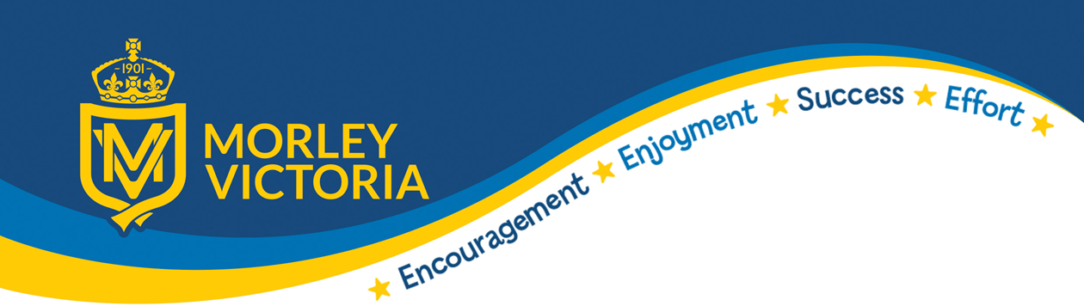
Stages of knowing words
How well do I know the word?
I’ve never heard the word before
I’ve heard this word but I don’t know what it means
I know what this word means but I can’t explain it.
I know what this word means and I can use it in a sentence.

KEY VOCABULARY
Rites of passage, confirmation, baptism, amrit, bar mitzvah, bat mitzvah, rights, responsibilities, Sikhism , Christianity, Judaism, adulthood, Khalsa

