How are important events remembered in ceremonies?
Photographs
WHAT WILL WE BE LEARNING? (KNOWLEDGE)

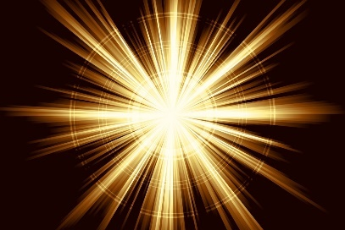
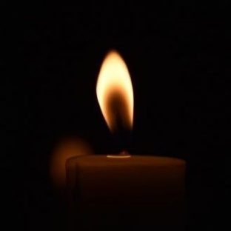
The children will learn about:
- The Jewish story of the Maccabees
- The Jewish celebration of Hanukkah
- The similarities and differences in faith stories
- The Hindu story of Ram and Sita
- How ‘light’ was important to the Ancient Greeks
- How the solstices are important to Pagans and others
- How light is used in other aspects of life for religious and
non-religious people

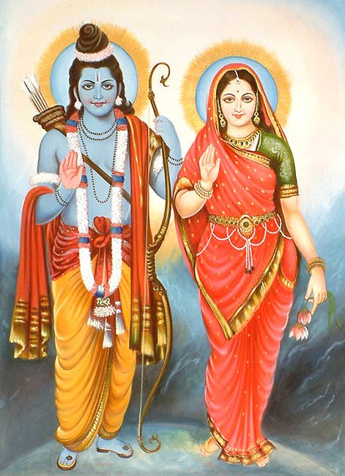

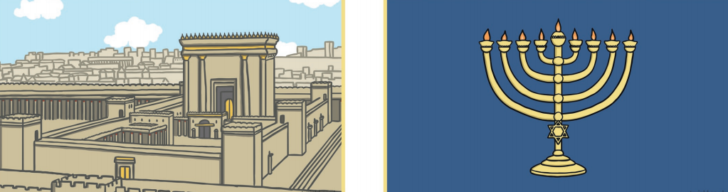

BOOKS

Various information texts to be read during reading fluency lessons and topic lessons to aid us in our research.
WHAT ARE THE KEY CONCEPTS?
CROSS CURRICULAR
Origin – We will learn about early Jewish, Hindu, Pagan and Greek history.
Beliefs – We will enquire the main beliefs in Judaism, Hinduism, Paganism and the Ancient Greek civilisation.
Worship – We will learn about the similarities and differences between celebrations in different faiths.
Tradition – We will learn about the traditions carried out by different religions, to commemorate events in the history of their religion.
Morality – We will discuss and respect the morals of different religious beliefs and celebrations.

English – Information Text Computing – Research skills
SMSC
Spiritual – Learning about and reflecting on their own and others’ beliefs about God and worship.
Moral – Expressing their own ideas about staying faithful and courageous – linked with the religious stories we will read.
Social – Considering how different people express what matters to them in different ways
Cultural – Promoting respect for all, understanding important stories and practices in different traditions

