Morley Victoria Primary School’s Physical education, school sport and physical activity (PESSPA) Transition report
At Morley Victoria, the school PE curriculum comprises a broad and balanced set of activities that have enabled the year 6 pupils to leave with a vast array of knowledge and understanding that allows them to be physically competent.
How would you describe yourself?
Pupils, please tick ANY of the comments below that matches your attitudes towards PE
- ATHLETIC - I understand how to lead a warmup, I know how important it is to be active, and I can transfer skills from one activity to another.

- A GOOD PARTICIPANT - I always bring my kit, I enjoy and look forward to PE

- A GOOD LEADER OR COACH – I like to help my friends during PE and I enjoy organising activities at break and lunch times.

- KNOWLEDGABLE - I know and understand the difference between PE, Sport and Physical Activity. I know how to lead an active lifestyle.

My time at Morley Victoria:
School clubs attended:
School team representation:
Community Clubs attended:
Other achievements:

At my new school, the thing about PE I am looking forward to most is:

At my new school I am going to try the following clubs:

Something I am unsure about is:

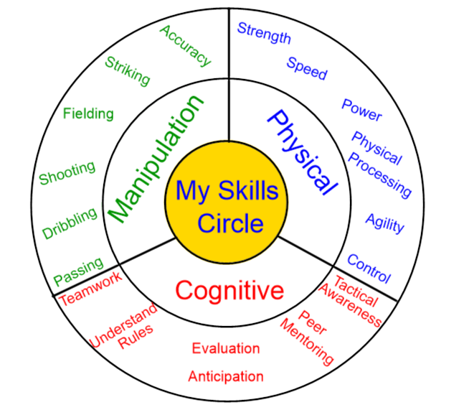
My Skills Circle:

During your PE lessons at school, you have been building up your Manipulation, Physical and Cognitive skillsets
These transferable skills are a vital part of building physical literacy, but which do you think are your strengths? Which do you feel you need to improve on?
- Circle 5 skills that you think are a strength of yours. They can be from any category.

- Underline 5 skills that you would like to build and improve upon when entering high school.
During your time at Morley Victoria you have taken part in:
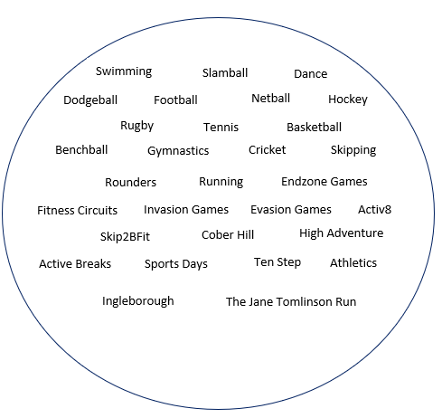

Please add in anything else to the circle that we have missed.

Good Luck and remember the importance of staying physically active!

