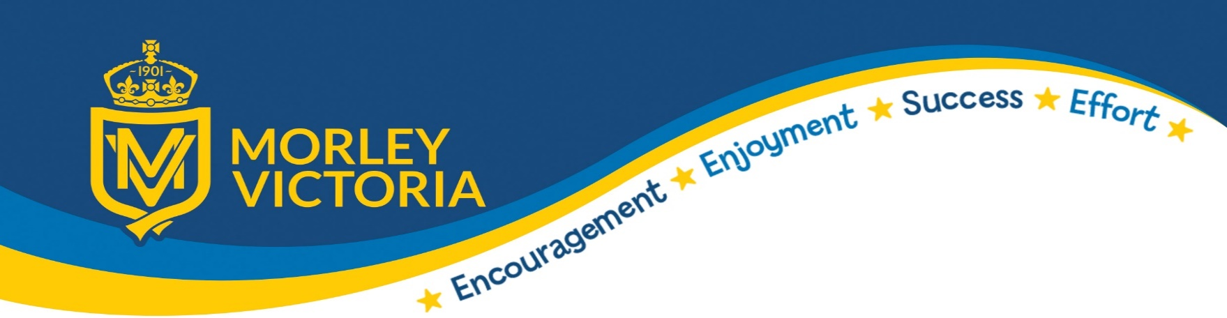
Intent, Impact and Implementation

Subject: Physical Education

Intent | Our intent is to provide the children with high quality physical education and school sport that will provide the children with the knowledge and skills to lead a healthy, active lifestyle and promote life-long participation within sport.
Implementation | Our curriculum aims to develop all children’s skills and abilities across a range of activities and sports (Spiral curriculum). The children will be given the opportunity to constantly improve their physical literacy and also develop the motivation and ability to use these skills across a wide range of activities. We want the children to experience competition and personal challenge and how to overcome and enjoy this. The children will also develop life skills such as team work and perseverance that they can then apply into other areas of school and life.
Impact | We want the children to find an activity that they are confident and comfortable in so the children take part in a wide range of sports throughout their time in school. We want the children to have a positive mind set towards a healthy active lifestyle and use this healthy mind-set across all areas of school life and moving forward.

