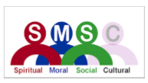
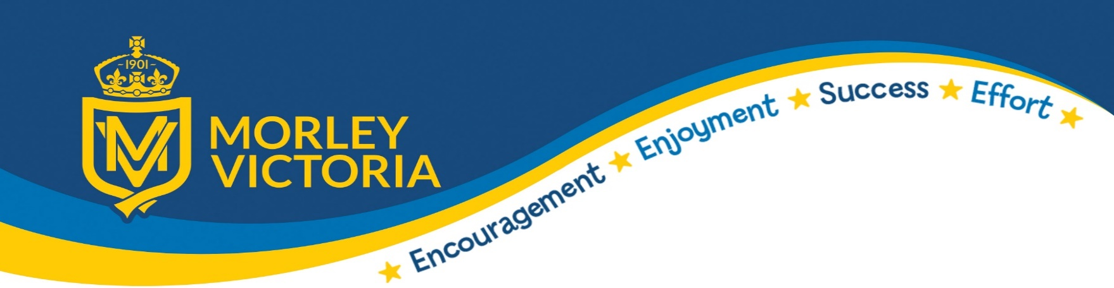




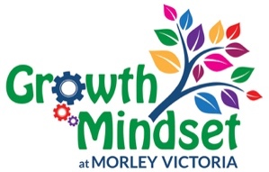
SMSC IN MATHEMATICS

In our Maths lessons at Morley Victoria Primary School pupils are encouraged to delve deeply into their understanding of Mathematics and how this subject is used all around us daily and how it links to jobs, careers and the world around us. We hold a career fair where children can talk to adults in industries from beauty to project management and recognise the role maths plays in their jobs. Our Maths teaching actively encourages risk taking and exploration which encourages learning from mistakes - which are ‘expected, respected, inspected and corrected’ in our classrooms- and aims to build resilience. This is fundamental to building pupils’ self-esteem within Mathematics as we expect mistakes to happen on their learning journey – emphasised by the power of ‘yet’. Throughout history, the study of Mathematics stems from intrigue and curiosity, with people’s desire to pose and solve problems relating to the real world or purely within mathematics itself. We begin our inquisitive journey from Nursery and EYFS with our MV Challenges provision. We aim for our students to appreciate this and use their own Maths to explore and question the way the world works and also to apply their reasoning to puzzles for their personal satisfaction – our growth mindset puzzle area always has children aiming to complete the challenge set for them.

Spiritual Development
- Developing deep thinking and questioning the way in which the world works promotes the spiritual growth of our students.
- We are sensitive to students’ individual needs and backgrounds and experience.
- We aim to give all students an appreciation of the richness and power of maths.
- Maths in nature is embedded in sequences, patterns and symmetry.
- We promote a sense of wonder in the exactness of mathematics in the exploration of complex numbers and real-world examples.
- We encourage the students to appreciate the enormity of the world of Mathematics as it has developed through time.
- Through our harvest services and charity days such as Harvest, Send a Cow and Hello Yellow we explore the impact of our donations and how they help others.
- We consider the development of pattern in different cultures including work on tessellations such as using Islamic isometric patterns.

Moral Development
- Within the classroom, we encourage respect, reward good behaviour. We value listening to others views and opinions on problem solving.
- We promote discussion about mathematical understanding and challenge assumptions, supporting students to question information and data that they are presented with.
- We show the students that we are on a quest for truth by rigorous and logical argument and discourage jumping to conclusions.
- We use figures to highlight moral issues encountered in assemblies, PSHE lessons and our weekly newspaper, The Week, such as climate change, endangered species and natural disasters.

Social Development
- In classrooms, we look for opportunities for pupils to use interactive resources (e.g. whiteboards, number fans, ICT) to promote self-esteem and build self-confidence when exploring new content.
- We encourage collaborative learning in the classroom – in the form of listening and learning from each other and paired discussion / working partners.
- We help pupils develop their mathematical voice and powers of logic, reasoning and explanation by offering explanations to each other and provide children with scaffolds so ALL children can offer their reasoning.
- We seek out events and team maths challenges for increased pupil involvement. (Aspire maths competitions, governor competitions, Numbers day challenges, TTRockstars challenges).
- We share pupils work in classrooms and celebrate their achievements in assemblies.

Cultural Development
- We share the appreciation with the pupils that mathematics, its language and symbols have developed from many different cultures around the world: eg Link this to number systems in history topics.

