

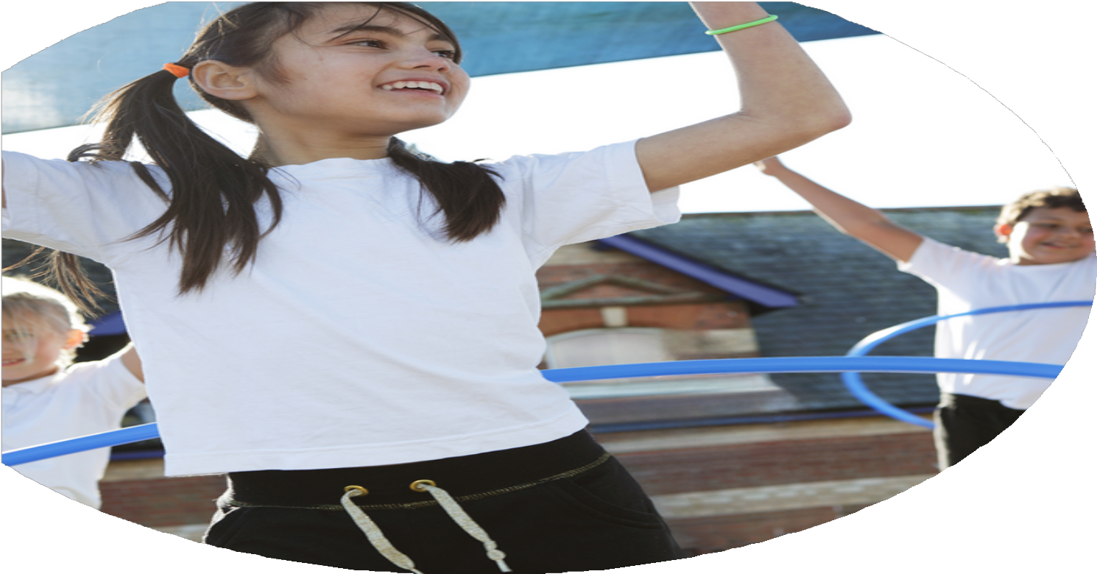
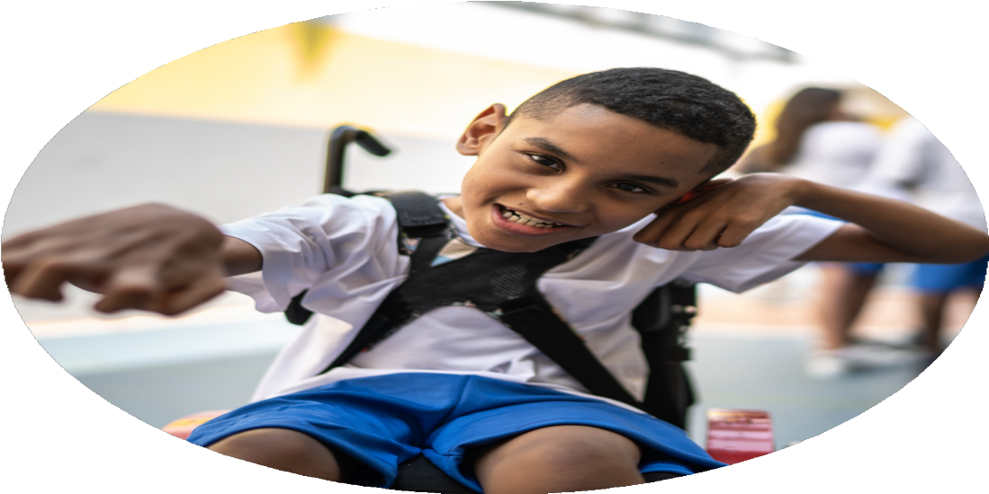




PE Funding

Evaluation Form

Commissioned by

Created by

Images courtesy of Youth Sport Trust

PE Funding Evaluation Form

It is intended that this template should be used as preparation for the completion of the statutory digital reporting tool being introduced this academic year. You can upload data (including swimming) from this template onto this platform once it becomes accessible.
Before you decide how you are going to use the funding for this academic year you should reflect and evaluate the impact of your use of the funding in 2023/24.
All spending of the funding must conform with the terms outlined in the Conditions of Grant document. The template is a working document that you can amend/update during the year.
Based on your evaluation of last year’s funding you should decide what you intend to do this academic year, how you will do it, and what impact you expect it to have.

It is important that the funding is used effectively and based on your school’s needs.
You must use the funding to make additional and sustainable improvements to the PE and sport in your school. You must develop and add to the PESSPA activities that your school already offers.

Summative digital reporting from June 2025 will continue to include swimming and water safety information therefore funding can be used to provide top-up lessons where necessary to ensure pupils meet national curriculum swimming requirements

What are your plans for 2024/25?

Intent
How are you going to action and achieve these plans?

Implementation
Use Move and learn resources in lessons and throughout the school day. To encourage being active throughout the day and support learning.

Increase the confidence and skill of teachers/ staff working in P.E lessons to ensure the delivery of high quality P.E. This will be done through the work with Leeds Well Schools and the training opportunities provided for all staff.

To offer a wider range of afterschool/ lunch clubs delivered.

Children to consistently get two hours of high-quality PE across all areas of the PE curriculum to help improve and develop their physical literacy from previous years.

To deliver whole school sporting to highlight the importance of being physically active and encourage enjoyment and love of sport.

To increase the profile of girls football across all ages in school.

Continue to deliver targeted interventions for children across school.
Training to be delivered throughout the year in staff meetings (2 organised for Autumn 1 to introduce ideas for staff). Monitor the delivery through monitoring of teaching and support through questionnaires for staff. Miss Young supported by Leeds Well Schools and the move and learn program.

P.E training sessions and staff meetings to be delivered throughout the school year. Year 4 teacher has taken part in swim teaching qualification to ensure knowledge has been developed to teach swimming.

Clubs organised to ensure a variety of activities planned. Mr Rhodes supporting at lunch times to organise activities for the children. Looking at PLAY resources to develop playtime opportunities. American Football club taking place.

This being supported by PE Partner and Leeds Rhinos Foundation to ensure all children in school are accessing 2 hours of high quality P.E

Continue to celebrate success of P.E and sporting achievement. Use pupil voice to develop the best opportunities in school that they want to access.

Time slots available for girls within school and girls football club organised.

Thursday am allocated to intervention time.

What impact/intended impact/sustainability are you
expecting?
How will you know? What evidence do you have or
expect to have?
Pupil and teacher voice. Learning walks of example activities. Sharing good practice.

Lesson observations and pupil voice.

Continue to monitor participation rates and see an increase in the number of children taking part.

Monitor activity and timetabled lessons throughout the year.

Pupil voice

Intervention results to be monitored and recorded according to the reason for intervention.
Use Move and learn resources in lessons and throughout the school day to support teachers in lessons to teach high quality lessons and support children with their learning.

Increase the confidence and skill of teachers/ staff working in P.E lessons to ensure the delivery of high quality P.E. This will be done through the work with Leeds Well Schools and the training opportunities provided for all staff.

To offer a wider range of afterschool/ lunch clubs delivered.

Children to consistently get two hours of high-quality PE across all areas of the PE curriculum to help improve and develop their physical literacy from previous years.

To deliver whole school sporting to highlight the importance of being physically active and encourage enjoyment and love of sport.

To increase the profile of girls football across all ages in school.

Continue to deliver targeted interventions for children across school.

What impact/sustainability have you seen?
What evidence do you have?

